KITH AND KIN INTERNATIONAL COLLEGE

*7/11 Kaoli Olusanya Street, Owode Ibeshe, Ikorodu, Lagos State.*

THIRD TERM EXAMINATION 2024/2025 ACADEMIC SESSION



|  |  |  |  |  |  |
| --- | --- | --- | --- | --- | --- |
| **NAME** |  | | | | |
| **SUBJECT** | AGRICULTURAL SCIENCE | **CLASS** | **JSS 3** | **DURATION** | **1 HOUR 30 MINS** |

*Answer* ***all*** *questions:* ***Each*** *question is followed by* ***four*** *options lettered* ***A*** *to* ***D****. Find out the correct option for* ***each*** *question and* ***shade*** *in* ***pencil*** *on your answer space which bears the same letter as the option you have chosen. Give only* ***one*** *answer to* ***each*** *question.*

1. Major insect pest of beans in the store is . A. grasshopper

B. weevil

C. beetle

D. aphid

2. The process of separating young animals from mother so that it can be fed independently is referred to as ….

A. kidding

B. culling

C. weaning

D. lambing 

3. A book or record in which farm transaction are firstly recorded before posted to their respective book is .

A. source document

B. journal

C. invoice

D. receipt

4. Red muscle on the head of cock is called ……

A. spur

B. wattle

C. comb

D. beak

5. Disease causing organisms are referred to as

A. parasites

B. vectors

C. predators

D, pathogen

5. Which of the following is not a pest?

1. Birds
2. Rodents
3. Insects
4. Earthworm

6. Agriculture is best described as .

A. crop cultivation and processing

B. art and science of crop production

C. crop production and rearing of farm animals

D. livestock production and product processing 

7. Which of the following is a characteristics of commercial, agriculture?

A. small parcel of land is required

B. intensive use of farm input

C. .family labour is used

D. total yield is usually low

8. Which of the following is NOT an insect pest on farmland?

A. Caterpillar

B. Beetle

C. Termite

D. Earthworm

9. Parasites cause the following symptoms in farm animals except

A. loss of appetite

B. high feeding habit

C. diarrhoea

D. loss of weight

10. Shell fish are the following except......

A. carps

B. crayfish

C. lobster

D. oyster

11. Which of the following is not an agro-allied industry?

A. Construction Company

B. Soap and detergent

C. Textile

D. Brewery

12. Two types of mixed cropping are and …..

A. crop rotational and inter cropping

B. intercropping and inter planting

C. continuous cropping and mono-cropping D. mono cropping and inter planting

13. Dams, well, fence, irrigation and drainage canals are referred to as .... structure.

A. processing

B. storage

C. utility

D. maintenance

14. Which of the following diseases cause abortion in cattle.

A. Aspergilosis

B. Bloat

C. Trypanosomiasis

D. Brucellosis

15. Daily activities performed in the farm is usually recorded in … . record.

A. input

B. consumption

C. sales

D. farm diary

1. Which of the following storage structure is shown in the image below?  
   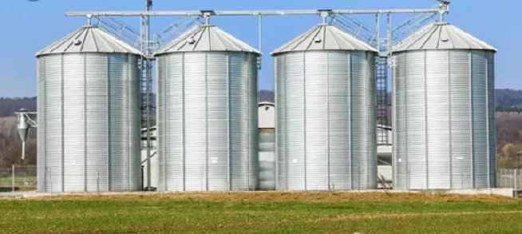
2. Rhombus
3. Barns
4. Silos
5. Fences
6. Cassava and yam tubers are better stored in which of the following?
7. Silos
8. Fences
9. Barns
10. Rhombus
11. Which of the following is the main difference between temporary farm buildings and permanent farm building?
12. Temporary farm buildings last longer than permanent farm buildings.
13. Temporary farm buildings are more expensive than permanent farm buildings.
14. Temporary farm buildings are inexpensive and easily constructed than permanent farm building.
15. Temporary farm buildings are made with plastic while permanent farm buildings are made with metals.

25. Mineral elements that are present in the nutrients of livestock in large quantities are called_____

1. micro-elements
2. macro-elements
3. non-mineral elements
4. diet

26. Which of the following feed contains high percentage of water and can digest easily in livestock?

1. Concentrate
2. Roughages
3. Succulents
4. Fats

27. Which of the following is not to be considered in choosing a farm site?

1. Availability of land
2. Presence of weed
3. Slope of the land
4. Security

28. The animal in the picture below is a/an

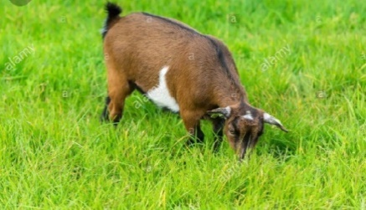

1. carnivore
2. omnivore
3. herbivore
4. viviparous

29. The picture below is an example of which of the following feed nutrients?  
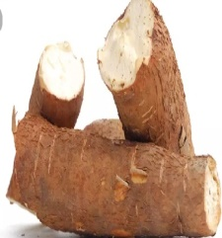 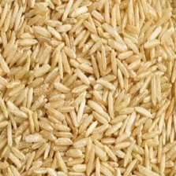

1. Protein
2. Carbohydrates
3. Vitamins
4. Minerals

30. ________ is an area where seeds are first grown and out in their permanent beds of fields. Tended till the seedlings are strong enough to be planted

1. Hatchery
2. Nursery
3. Stock
4. Scion

31. The vitamin that is present in the nutrients of livestock that help in clothing of blood is vitamin

1. B
2. C
3. D
4. K

32. Which of the following farm produce requires cold storage?

A. cowpea

B. rice

C. sweet potato

D. tomato

33. The transfer of crop seedlings from the nursery to the permanent site from proper planting is called

A. transplanting

B. supplying

C. transfer

D. thinning

34. Which of the following is not a cereals feed?

1. Maize
2. Rice
3. Millet
4. Hay

35. The total supply of feed given to a farm animal in a period of 24hours is called _____

1. ration
2. diet
3. feed
4. balanced diet

36. Which of the following feeding tools or equipment is used mainly for fattening cattle?

1. Drinkers
2. Bunks
3. Self-feeders
4. Hay racks

37. It is important to clean feeding tools for livestock for which the following reason except? To

1. prevent livestock from been infected with diseases.
2. avoid poor growth in livestock
3. cause diseases in livestock
4. improve overall productivity.

38. Which of the following feeding tools is not needed in the poultry?

1. Feed trough
2. Hay racks
3. Drinkers
4. Self-feeders

39. The following are the products obtained from

Farm animals, except

1. meat
2. milk
3. egg
4. fruit

40. Manures prepared from plant and animal refuse is called ________

1. inorganic manure
2. organic manure
3. farm yard manure
4. plant and animal manure

41. An organism living in or on another organism which derive benefits from the host while the host is harmed is known as _____

1. Pest
2. Parasite
3. Disease
4. livestock

42. Disease causing micro-organisms in livestock is a called ____

1. vector
2. pathogen
3. rodent
4. nematode

43. Which of the following is a disease of farm animal caused by protozoan?

1. Anthrax
2. Gastro enteritis
3. Trpanosomiasis
4. Coccidiosis

44. Which of the following disease is caused by fungi?

1. Aspergillosis
2. Babesiosis
3. Mastitis
4. Tuberculosis

45. The following are the agricultural practices in

West Africa except __________

1. Hunting
2. Fishing
3. Crop cultivation
4. Weed cultivation

46. All of the following are branches of agriculture except

1. Crop science
2. Soil science
3. Horticulture
4. Hunting

47. The following are importance of agriculture to farmers except

1. It serve a source of food
2. It provides employment opportunity
3. It provide shelter
4. It provides foreign exchange

Use the image below to answer question **48** and **49**.

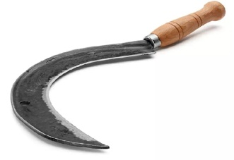

48. The name of the farm tool above is ____

A. spade

B. sickle

C. hand trowel

D. axe

49. Which of the following best describe the function of the tool above?

1. It is used to trim grasses
2. It is used to harvest yam
3. It is used to kill cow
4. It is used harvest grain crops

50. Maize is an example of

1. monocotyledon
2. dicotyledon
3. polycotyledon
4. cash crop